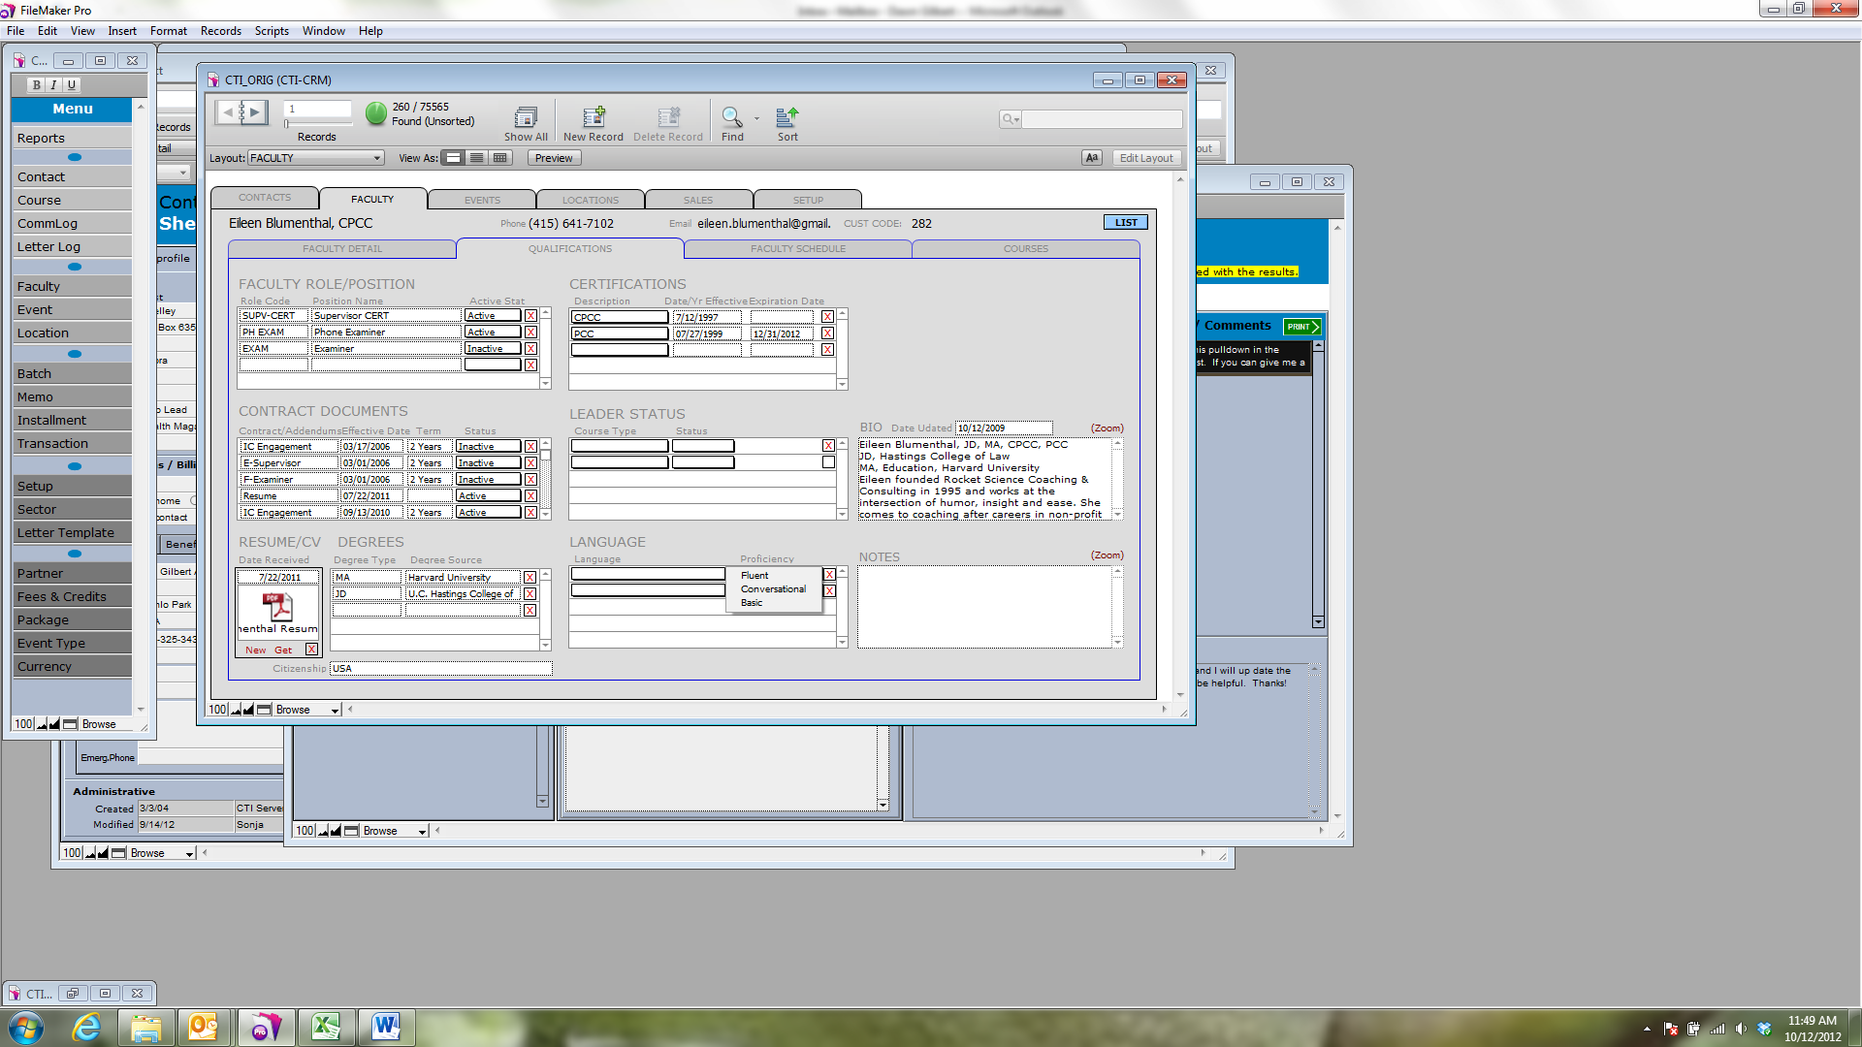

Please add “Native” to this list. Thank you!